**Database Management System Lab (Week1_Spring 2023)**

**Department of Computer Science**



**Learning Objectives:**

* Installation of SQL server and SSMS.
* Create a new database

1. Introduction**:**

Database system is a collection of **Database** and **DBMS.**

**Database:**

Collection of *related* data.

For example, Banks have the information of their respective users.

**Database Management Systems (DBMS)**

A system that provides ease to the user to access data and perform operations on it. The operations include:

* Insertion
* Update
* Deletion

**Example:** SQL Server, MySQL, Oracle etc.

In this lab, we will learn about SQL Server and do its installation.

1. Installation guide  
   ______________________________________________________________________________________________

Important Note:

* 1. connect your system with internet and download the developer edition using this given link: <https://www.microsoft.com/en-us/sql-server/sql-server-downloads>
  2. Login on window with as Administrator

Figure 1: SQL downloading version

* 1. Once downloaded then click on the .exe file and run.

* 1. Then click on Basic version to install.

Figure 2: Selection of basic version

* 1. Scroll down and then click on accept.

Figure 3: Terms and conditions for installing SQL Server

* 1. Click on Install and eat pop corns until installation is done. 😊

Figure 4: Starting the installation process by clicking on install button

While the installation is going on in the background let us revise a Database, we are familiar with, i.e., **File Handling.**

1. **Write a C++ code to make a file having following data (using File handling)**

|  |  |  |  |  |
| --- | --- | --- | --- | --- |
| **ID** | **FirstName** | **LastName** | **Age** | **Gender** |
| 1 | Ali | Akram | 24 | Male |
| 2 | Ahmed | Khan | 22 | Male |
| 3 | Ayesha | Batool | 21 | Female |

1. **Retrieve the data having firstName equals to Ali**
   1. After installation is done click on install SSMS

Figure 5: Installation has completed successfully

* 1. Click on highlighted link. It will download .exe file of SSMS. After downloading run .exe file.

Figure 6: Version of SSMS for installation

* 1. Click on Install and wait until installation is done successfully.

Figure 7: Installation of SSMS

# Generate Scripts of a schema _______________________________________________________________________________________________

* **Step 1**

Right click on your database and select Task -> generate script.

Figure 8: Database_Scripts_With_Data_Select_Option

* **Step 2**

Click next in the introduction screen

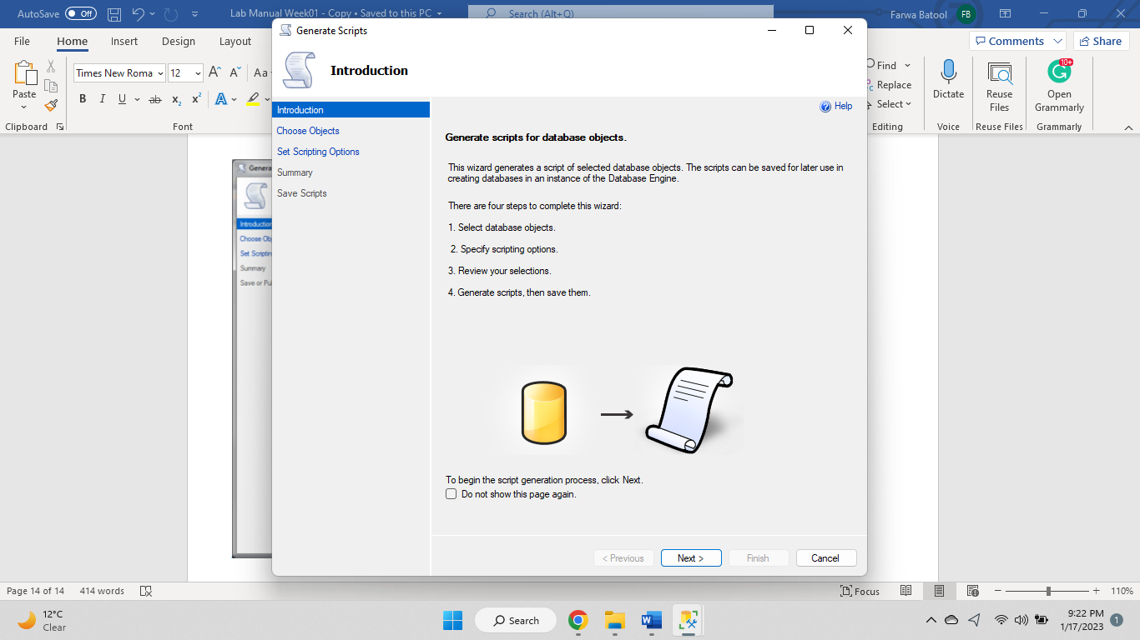

Figure 9: Database_Scripts_With_Data_Introduction

* **Step 3**

Select the database object which you are all you need and then click next.

Figure 10: Selecting database objects

* **Step 4**

Now you will be shown a window which asks you about how your script should be published.

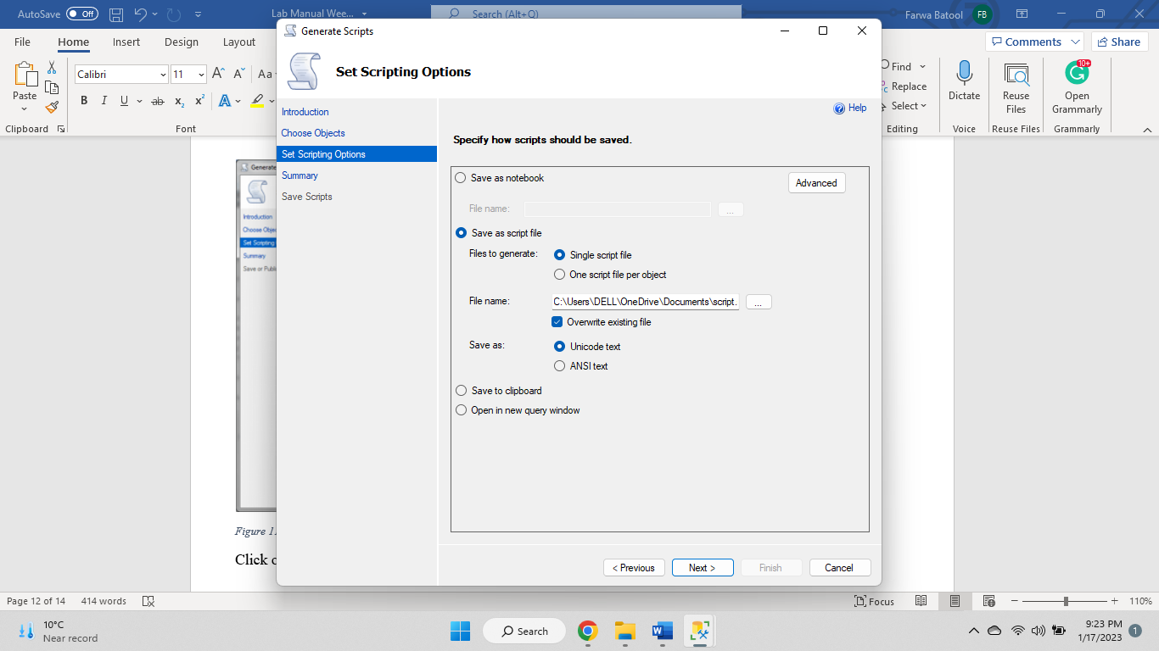

Figure 11: Database_Scripts_With_Data_Publish_Options

Click on advanced in that window.

* **Step 5**

Select ‘Schema and data’ from type of data to script option and then click OK.

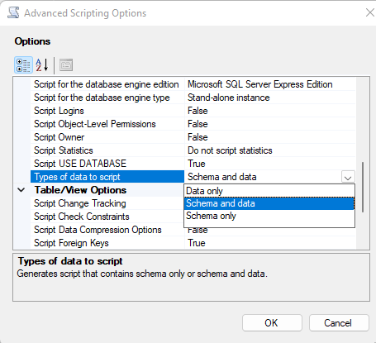

Figure 12: Database_Scripts_With_Data_Advanced

Click on Next.

* **Step 6**

Click finish, now check the script file, it must be having the insert queries too.

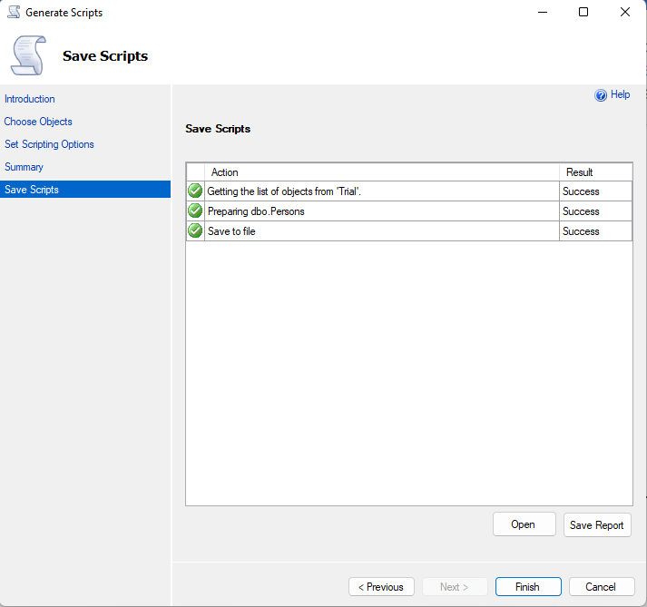

Figure 13: Database_Scripts_With_Data_Finish

Now what else is pending, go ahead and run your script.

# 4. Lab Tasks __________________________________________________________________________________________________

1. Install Microsoft SQL server

2. Install SSMS

3. Create a new database named TestDB_2021_SE_X

*X being your registration number*